Module 1 – SQL

Normalization

Entity Diagram

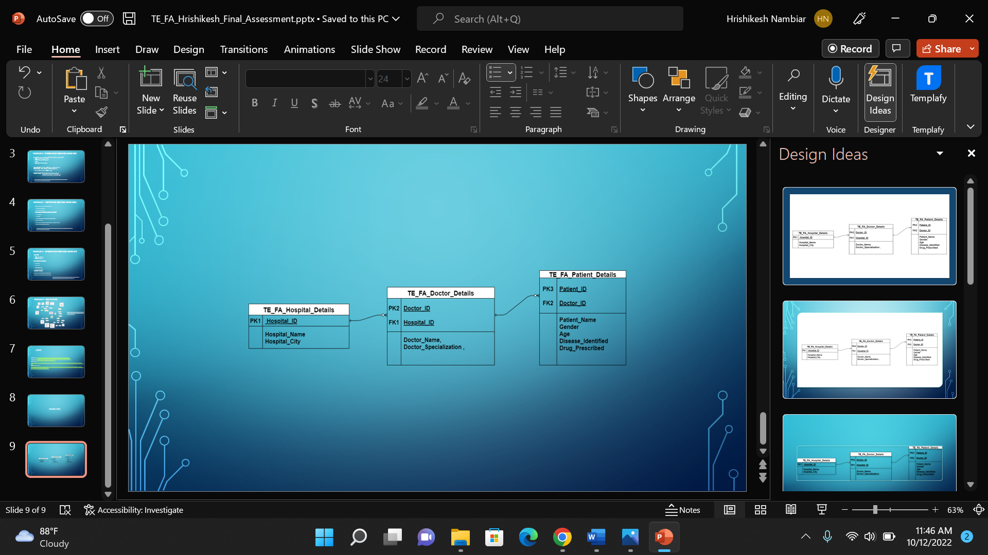

Create Tables

**create** **table** TE_FA_Hospital_Details

(

Hospital_ID **int** **primary** **key**,

Hospital_Name **varchar**(100),

Hospital_City **varchar** (100),

)

**create** **table** TE_FA_Doctor_Details

(

Doctor_ID **int** **primary** **key**,

Doctor_Name **varchar**(100),

Doctor_Specialization **varchar**(100),

Hospital_ID **int**,

)

**create** **table** TE_FA_Patient_Details

(

Patient_ID **int** **primary** **key**,

Patient_Name **varchar**(100),

Gender **varchar**(100),

Age **int**,

Disease_Identified **varchar**(100),

Drug_Prescribed **varchar**(100),

Doctor_ID **int**,

)

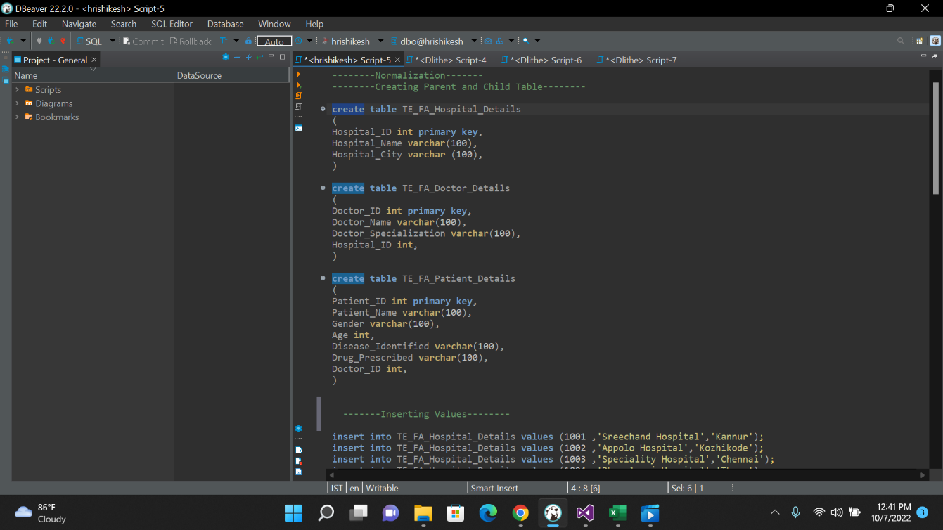

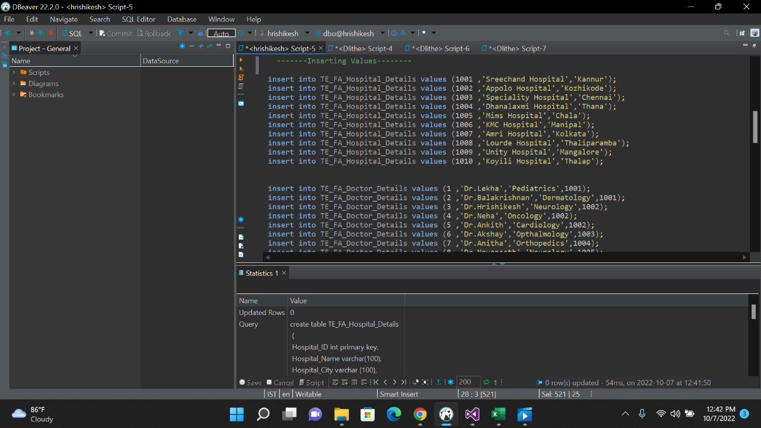

Inserting Values into Tables

**insert** **into** TE_FA_Hospital_Details **values** (1001 ,'Sreechand Hospital','Kannur');

**insert** **into** TE_FA_Hospital_Details **values** (1002 ,'Appolo Hospital','Kozhikode');

**insert** **into** TE_FA_Hospital_Details **values** (1003 ,'Speciality Hospital','Chennai');

**insert** **into** TE_FA_Hospital_Details **values** (1004 ,'Dhanalaxmi Hospital','Thana');

**insert** **into** TE_FA_Hospital_Details **values** (1005 ,'Mims Hospital','Chala');

**insert** **into** TE_FA_Hospital_Details **values** (1006 ,'KMC Hospital','Manipal');

**insert** **into** TE_FA_Hospital_Details **values** (1007 ,'Amri Hospital','Kolkata');

**insert** **into** TE_FA_Hospital_Details **values** (1008 ,'Lourde Hospital','Thaliparamba');

**insert** **into** TE_FA_Hospital_Details **values** (1009 ,'Unity Hospital','Mangalore');

**insert** **into** TE_FA_Hospital_Details **values** (1010 ,'Koyili Hospital','Thalap');

**insert** **into** TE_FA_Doctor_Details **values** (1 ,'Dr.Lekha','Pediatrics',1001);

**insert** **into** TE_FA_Doctor_Details **values** (2 ,'Dr.Balakrishnan','Dermatology',1001);

**insert** **into** TE_FA_Doctor_Details **values** (3 ,'Dr.Hrishikesh','Neurology',1002);

**insert** **into** TE_FA_Doctor_Details **values** (4 ,'Dr.Neha','Oncology',1002);

**insert** **into** TE_FA_Doctor_Details **values** (5 ,'Dr.Ankith','Cardiology',1002);

**insert** **into** TE_FA_Doctor_Details **values** (6 ,'Dr.Akshay','Opthalmology',1003);

**insert** **into** TE_FA_Doctor_Details **values** (7 ,'Dr.Anitha','Orthopedics',1004);

**insert** **into** TE_FA_Doctor_Details **values** (8 ,'Dr.Navaneeth','Neurology',1005);

**insert** **into** TE_FA_Doctor_Details **values** (9 ,'Dr.Ashwin','Surgeon',1006);

**insert** **into** TE_FA_Doctor_Details **values** (10 ,'Dr.Roshin','Psychiatry',1006);

**insert** **into** TE_FA_Doctor_Details **values** (11 ,'Dr.Ram','Pediatrics',1007);

**insert** **into** TE_FA_Doctor_Details **values** (12 ,'Dr.Nainitha','Family Medicine',1008);

**insert** **into** TE_FA_Doctor_Details **values** (13 ,'Dr.Nidhi','Dermatology',1008);

**insert** **into** TE_FA_Doctor_Details **values** (14 ,'Dr.Sreelakshmi','Plastic Surgery',1009);

**insert** **into** TE_FA_Doctor_Details **values** (15 ,'Dr.Jane','Orthopedics',1010);

**insert** **into** TE_FA_Doctor_Details **values** (16 ,'Dr.Mashitha','Opthalmology',1010);

**insert** **into** TE_FA_Patient_Details **values** (101 ,'Afnan','Male',19,'Brain','Acetaminophen',3);

**insert** **into** TE_FA_Patient_Details **values** (102 ,'Shyam','Male',18,'Skin','Metaformin',2);

**insert** **into** TE_FA_Patient_Details **values** (103 ,'Niharika','Female',21,'Eye','Ativan',6);

**insert** **into** TE_FA_Patient_Details **values** (104 ,'Sreelakshmi','Female',19,'Eye','Ativan',16);

**insert** **into** TE_FA_Patient_Details **values** (105 ,'Arun','Male',22,'Bone','Albuterol',7);

**insert** **into** TE_FA_Patient_Details **values** (106 ,'Shradha','Female',35,'Skin','Metaformin',2);

**insert** **into** TE_FA_Patient_Details **values** (107 ,'Sinan','Male',41,'Brain','Acetaminophen',8);

**insert** **into** TE_FA_Patient_Details **values** (108 ,'Hrithik','Male',29,'Mind','Codeine',10);

**insert** **into** TE_FA_Patient_Details **values** (109 ,'Nithin','Male',22,'Teeth','Januvia',4);

**insert** **into** TE_FA_Patient_Details **values** (110 ,'Rhithka','Female',28,'Pregnancy','Allegra',9);

**insert** **into** TE_FA_Patient_Details **values** (111 ,'Athulya','Female',19,'Eye','Ativan',6);

**insert** **into** TE_FA_Patient_Details **values** (112 ,'Anamika','Female',19,'Viral Fever','Adderal',12);

**insert** **into** TE_FA_Patient_Details **values** (113 ,'Reuben','Male',47,'Heart','Prednisone',5);

**insert** **into** TE_FA_Patient_Details **values** (114 ,'Shamil','Male',9,'Viral Fever','Balladona',1);

**insert** **into** TE_FA_Patient_Details **values** (115 ,'Sreerag','Male',56,'Brain','Acetaminophen',8);

**insert** **into** TE_FA_Patient_Details **values** (116 ,'Shakhin','Male',17,'Bone','Albuterol',15);

**insert** **into** TE_FA_Patient_Details **values** (117 ,'Sidharth','Male',20,'Heart','Prednisone',5);

**insert** **into** TE_FA_Patient_Details **values** (118 ,'Nischitha','Female',23,'Heart','Prednisone',5);

**insert** **into** TE_FA_Patient_Details **values** (119 ,'Sayeed','Male',23,'Viral fever','Adderal',12);

**insert** **into** TE_FA_Patient_Details **values** (120 ,'Nada','Female',19,'Pregnancy','Allegra',9);

**insert** **into** TE_FA_Patient_Details **values** (121 ,'Saarthak','Male',30,'Eye','Ativan',16);

**insert** **into** TE_FA_Patient_Details **values** (122 ,'Sakshat','Male',29,'Brain','Acetaminophen',3);

**insert** **into** TE_FA_Patient_Details **values** (123 ,'Nithya','Female',37,'Teeth','Januvia',4);

**insert** **into** TE_FA_Patient_Details **values** (124 ,'Pooja','Female',50,'Mind','Codeine',10);

**insert** **into** TE_FA_Patient_Details **values** (125 ,'Minaz','Female',19,'Skin','Metaformin',14);

**insert** **into** TE_FA_Patient_Details **values** (126 ,'Shivani','Female',19,'Bone','Albuterol',15);

**insert** **into** TE_FA_Patient_Details **values** (127 ,'Sana','Female',60,'Brain','Acetaminophen',3);

**insert** **into** TE_FA_Patient_Details **values** (128 ,'Aravind','Male',45,'Brain','Acetaminophen',3);

**insert** **into** TE_FA_Patient_Details **values** (129 ,'Shafan','Male',54,'Skin','Prednisone',13);

**insert** **into** TE_FA_Patient_Details **values** (130 ,'Jenny','Female',19,'Heart','Ibupofen',11);

**insert** **into** TE_FA_Patient_Details **values** (131 ,'Sreelal','Male',22,'Teeth','Januvia',4);

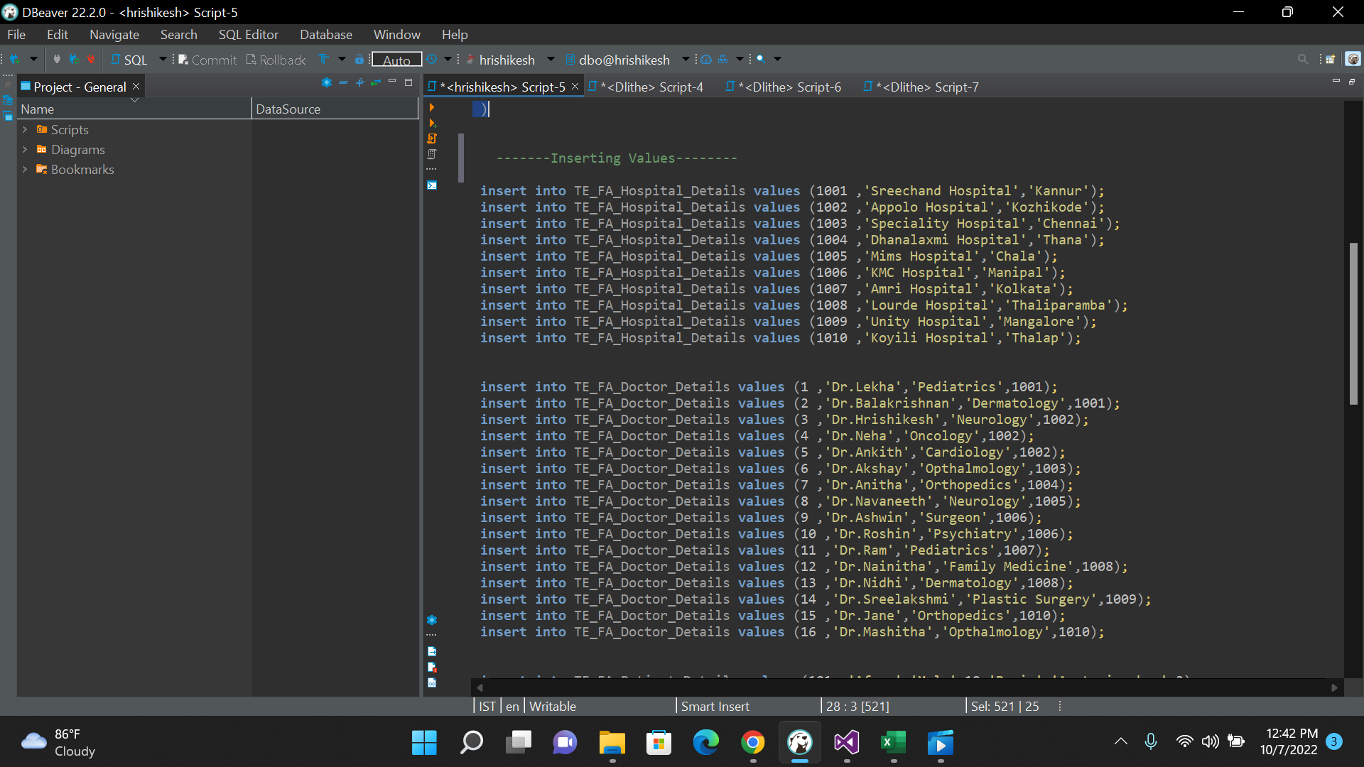

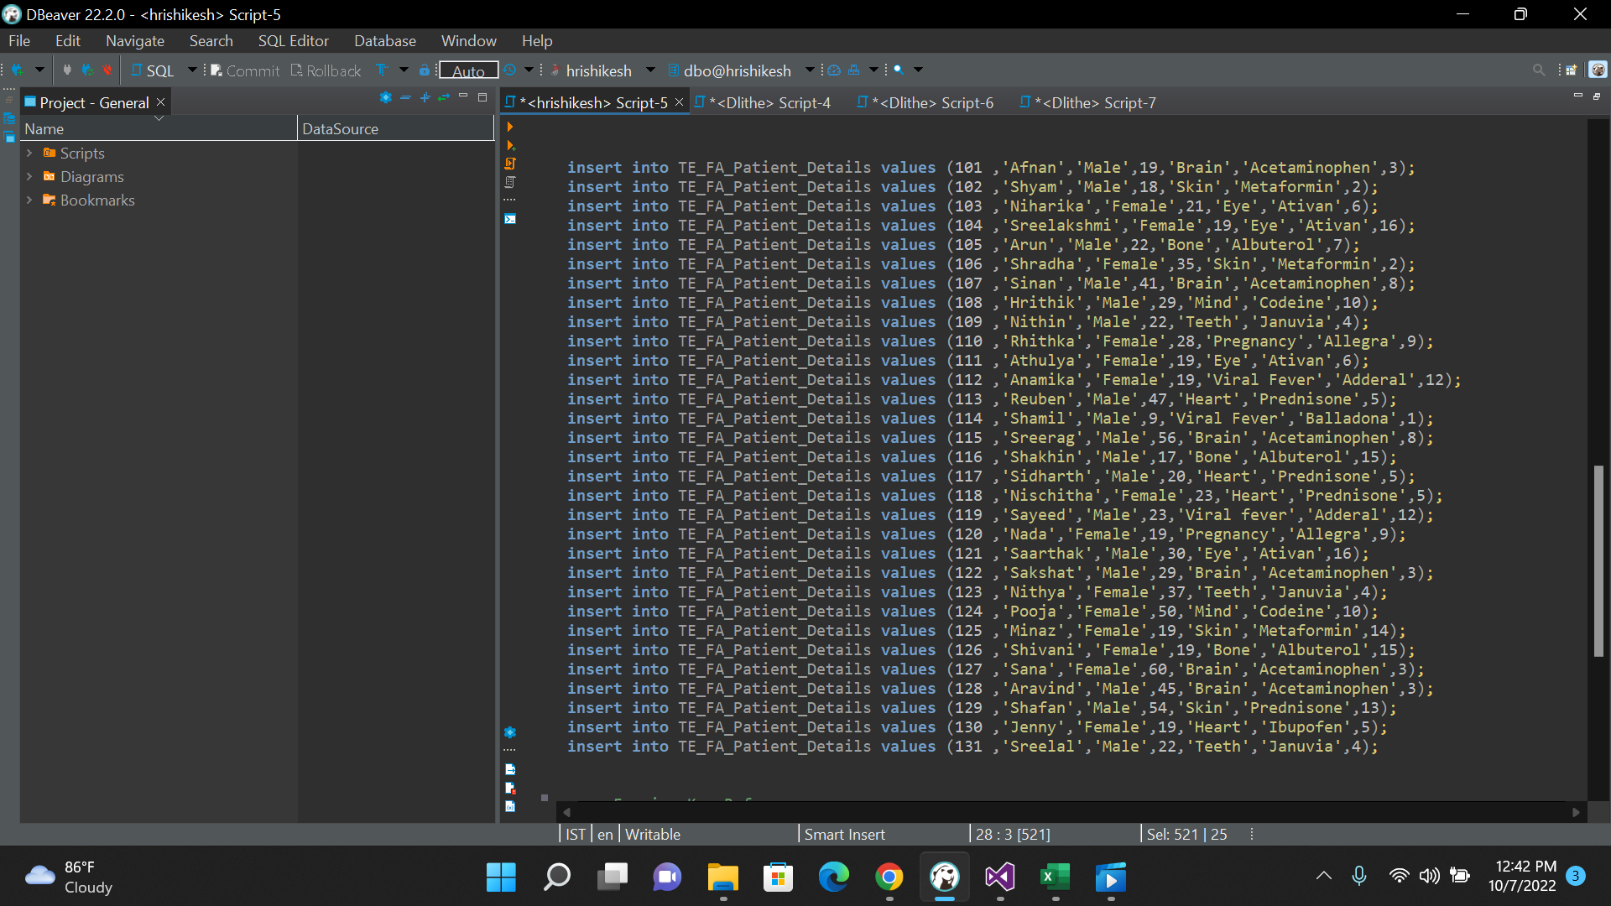

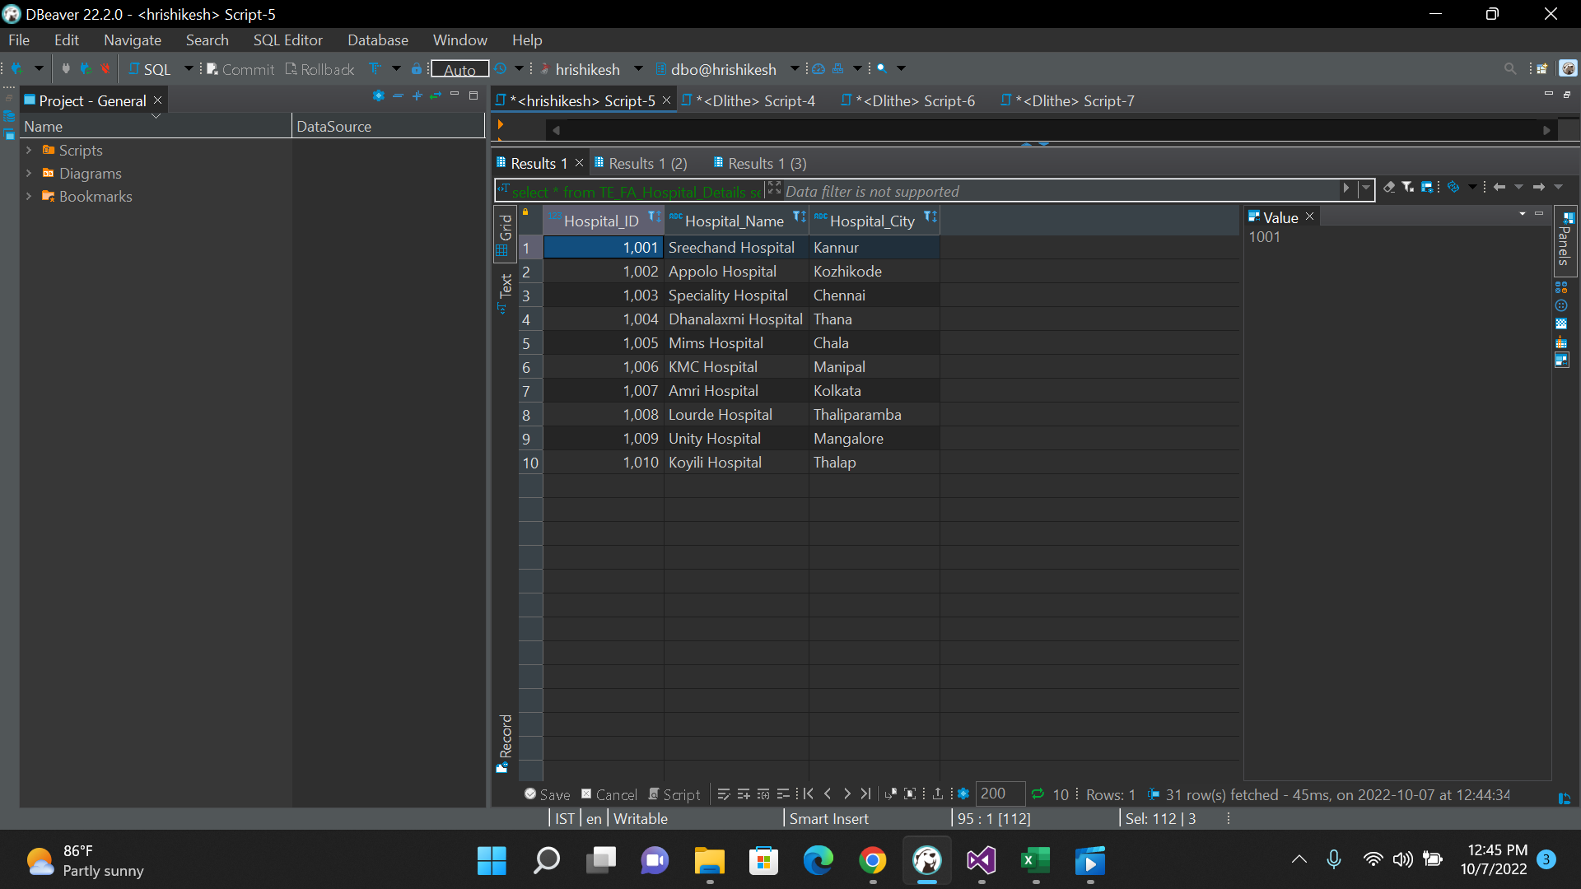

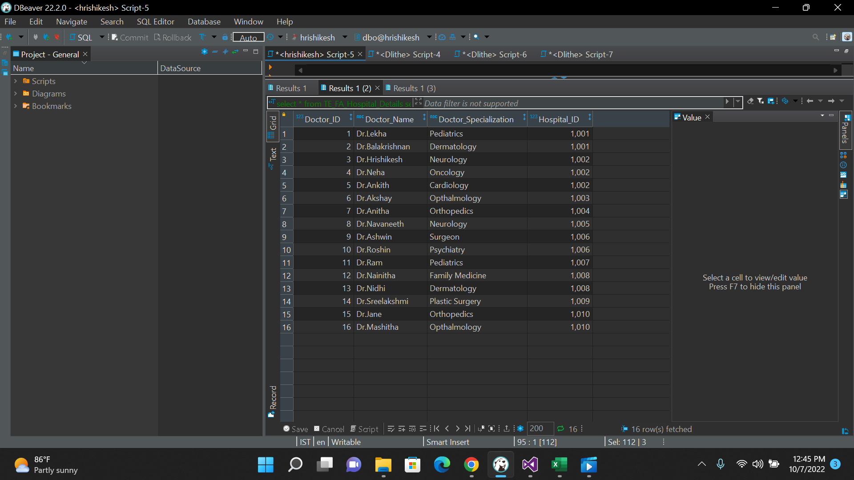

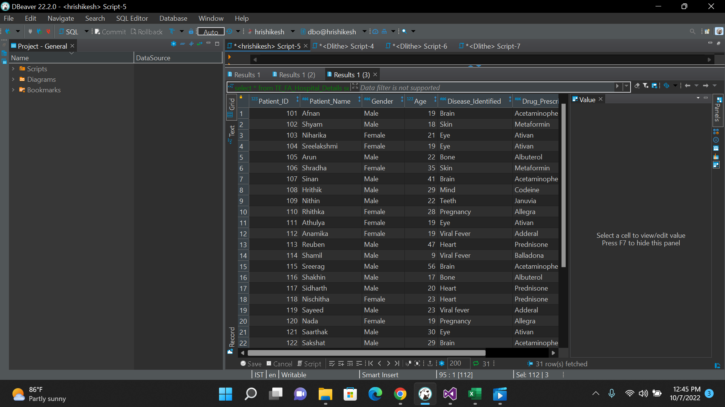

Constraints

------Foreign Key Reference--------

**select** * **from** TE_FA_Hospital_Details

**select** * **from** TE_FA_Doctor_Details

**alter** **table** TE_FA_Doctor_Details

**add** **constraint** FK_hospital

**foreign** **key** (Hospital_ID) **references** TE_FA_Hospital_Details(Hospital_ID)

**select** * **from** TE_FA_Doctor_Details

**select** * **from** TE_FA_Patient_Details

**alter** **table** TE_FA_Patient_Details

**add** **constraint** FK_doctor

**foreign** **key** (Doctor_ID) **references** TE_FA_Doctor_Details(Doctor_ID)

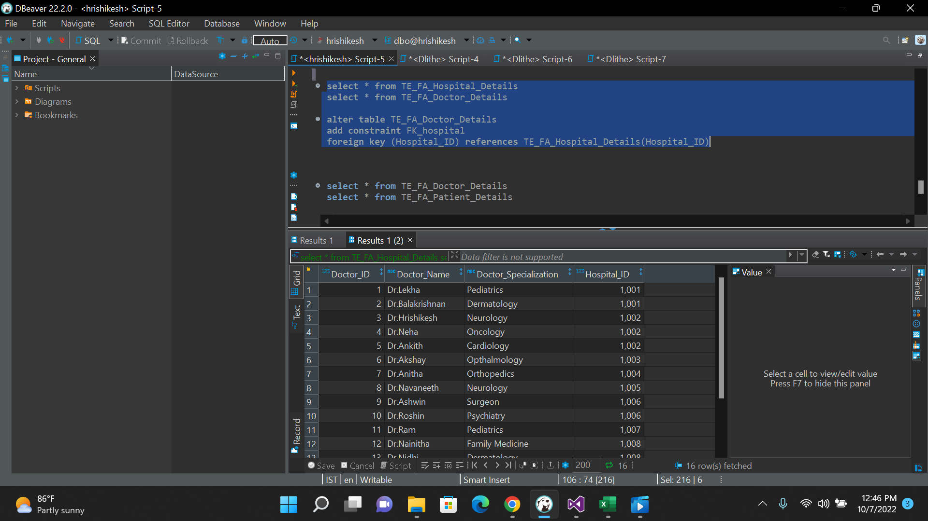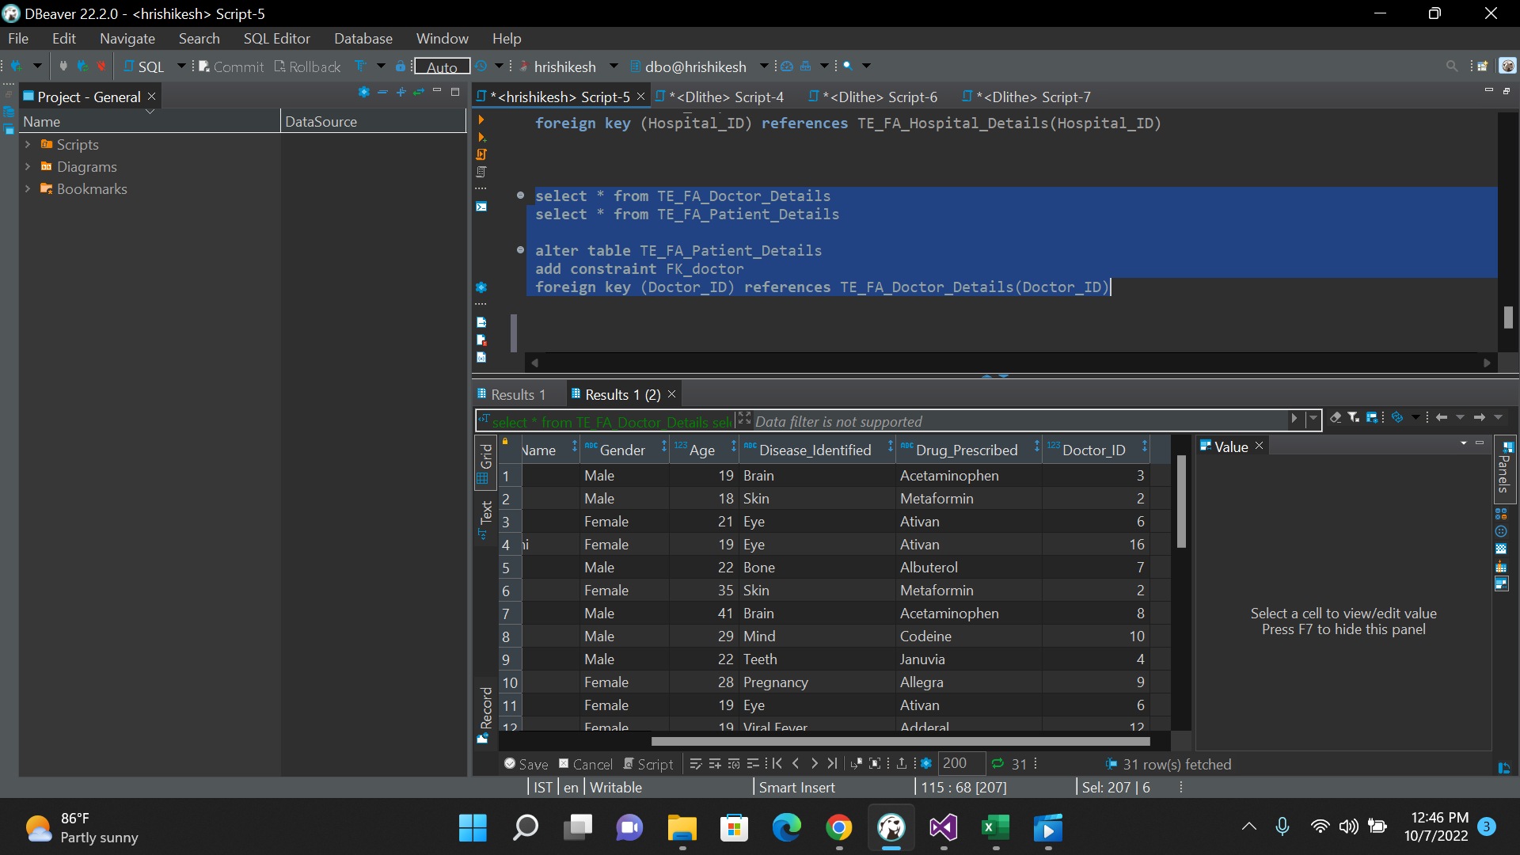

Creating Views

Inner Join

------Inner Join--------

**Select** D.Doctor_ID , D.Doctor_Name , D.Doctor_Specialization , D.Hospital_ID, P.Doctor_ID,

P.Patient_Name

**from** TE_FA_Doctor_Details **as** D

**inner** **join** TE_FA_Patient_Details **as** P

**on** D.Doctor_ID=P.Doctor_ID

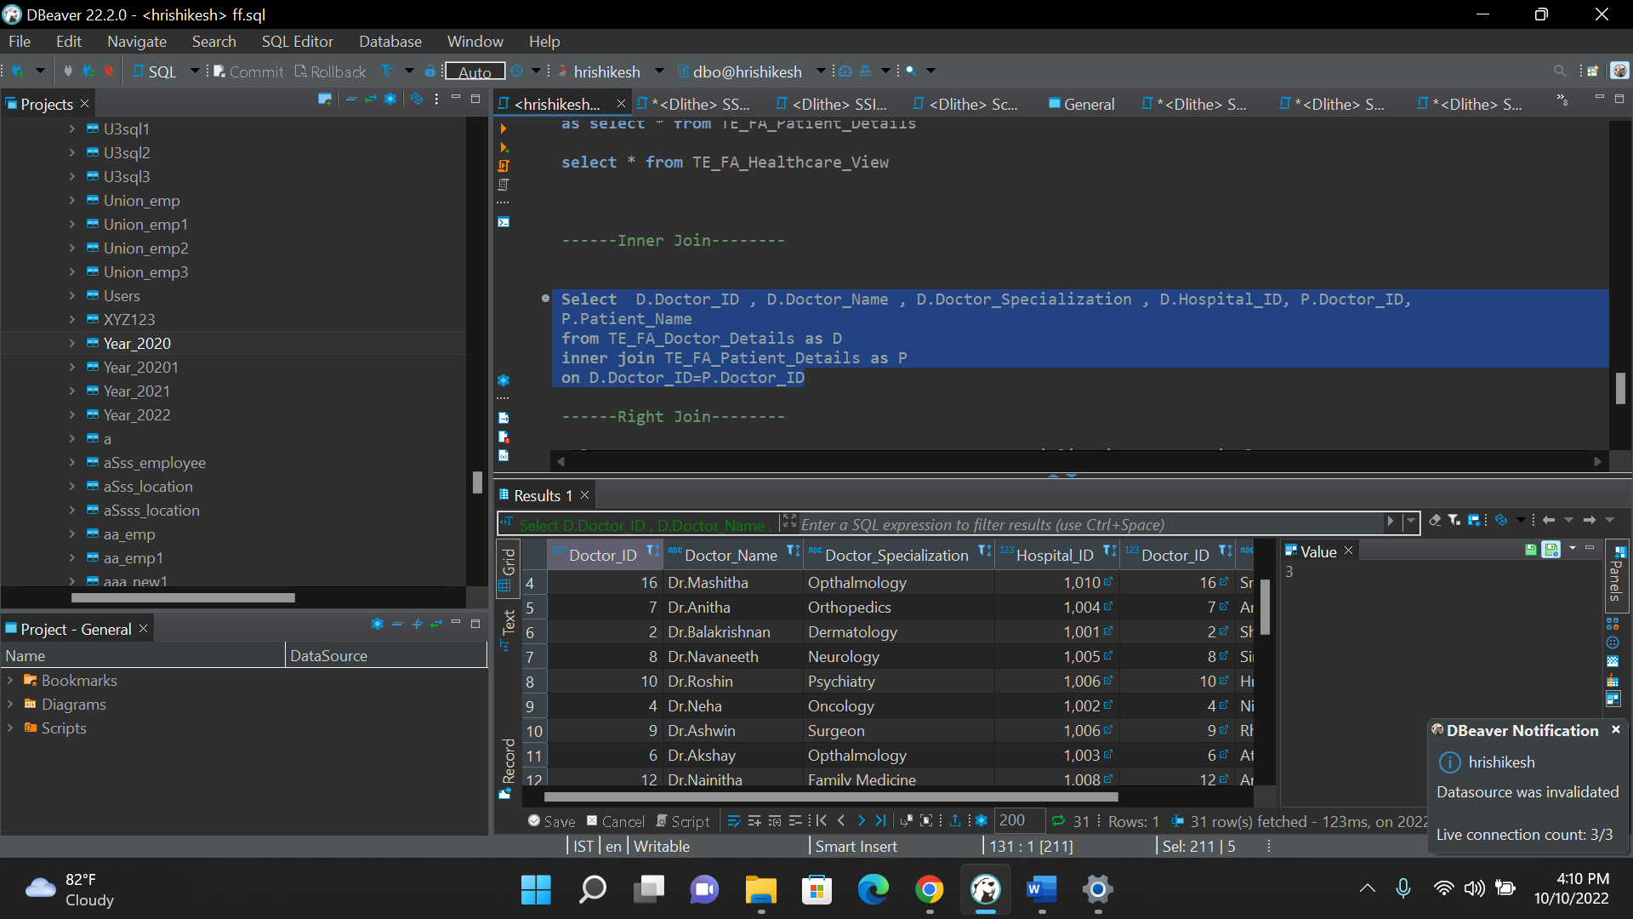

Right Join

------Right Join--------

**Select** D.Doctor_ID , D.Doctor_Name , D.Doctor_Specialization , D.Hospital_ID, P.Doctor_ID,

P.Patient_Name

**from** TE_FA_Doctor_Details **as** D

**right** **join** TE_FA_Patient_Details **as** P

**on** D.Doctor_ID=P.Doctor_ID

Full Join

**Select** D.Doctor_ID , D.Doctor_Name , D.Doctor_Specialization , D.Hospital_ID, P.Doctor_ID,

P.Patient_Name

**from** TE_FA_Doctor_Details **as** D

**full** **join** TE_FA_Patient_Details **as** P

**on** D.Doctor_ID=P.Doctor_ID

